Task on AWS-AutoScalling
- Create one VPC in N. Virginia region.
Created a VPC in US East (N. Virginia) region
Configured CIDR block and network settings
Verified successful creation
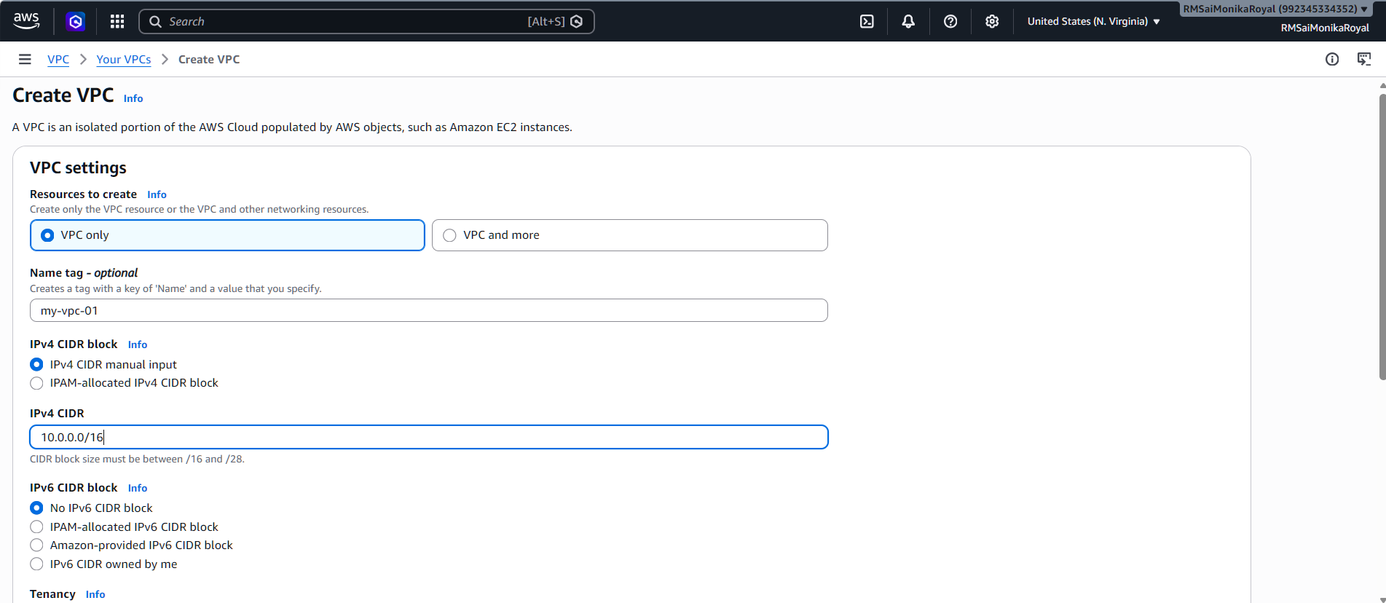
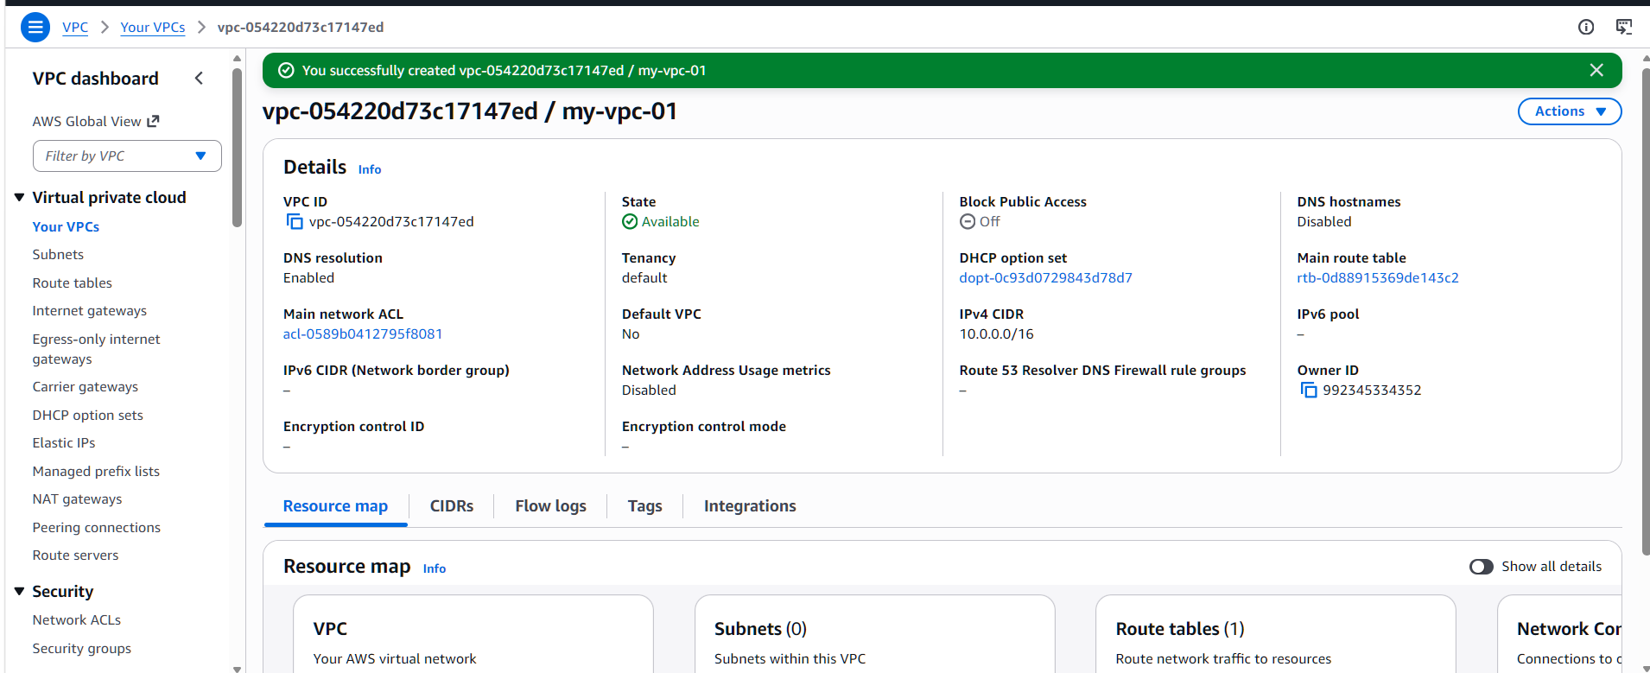
- Create two subnets: one public subnet and one private subnet.
Created two subnets inside VPC
Configured one public subnet and one private subnet
Assigned unique CIDR blocks to avoid overlap
Used different Availability Zones for reliability
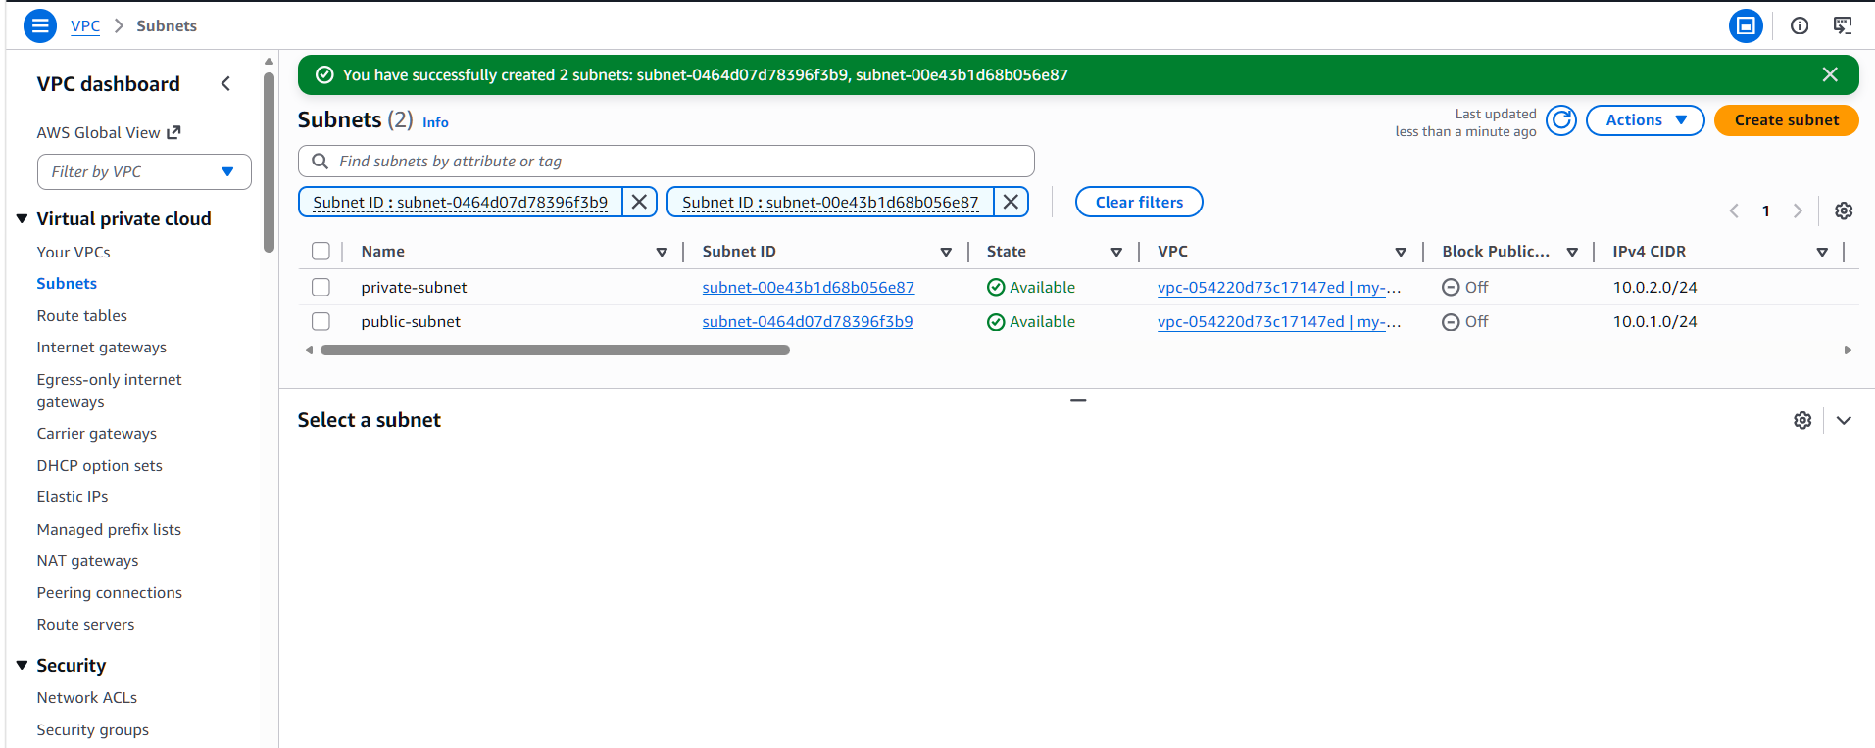
- Attach an IGW to the VPC.
Created an Internet Gateway
Attached IGW to the VPC
Enabled internet connectivity for the VPC
Prepared network for public access configuration
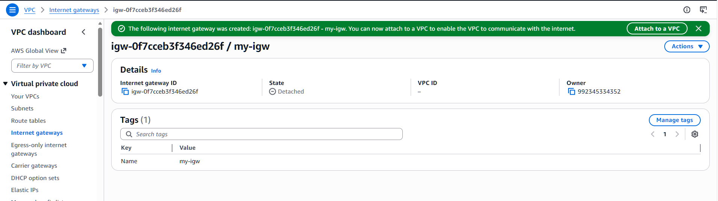
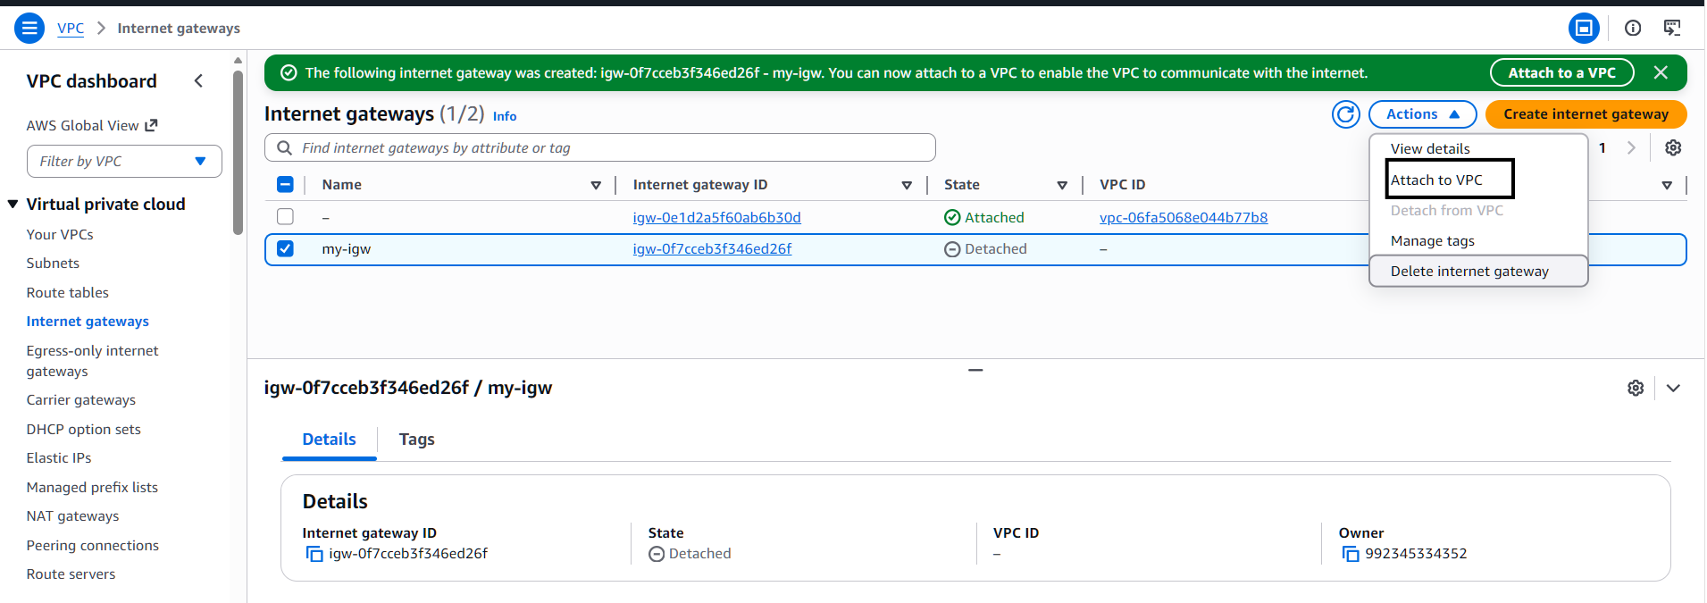
- Create one public route table (RT) and one private route table.
Created Public and Private Route Tables
Configured internet route for Public RT
Associated Public RT with Public Subnet
Associated Private RT with Private Subnet
Ensured proper traffic routing and network isolation
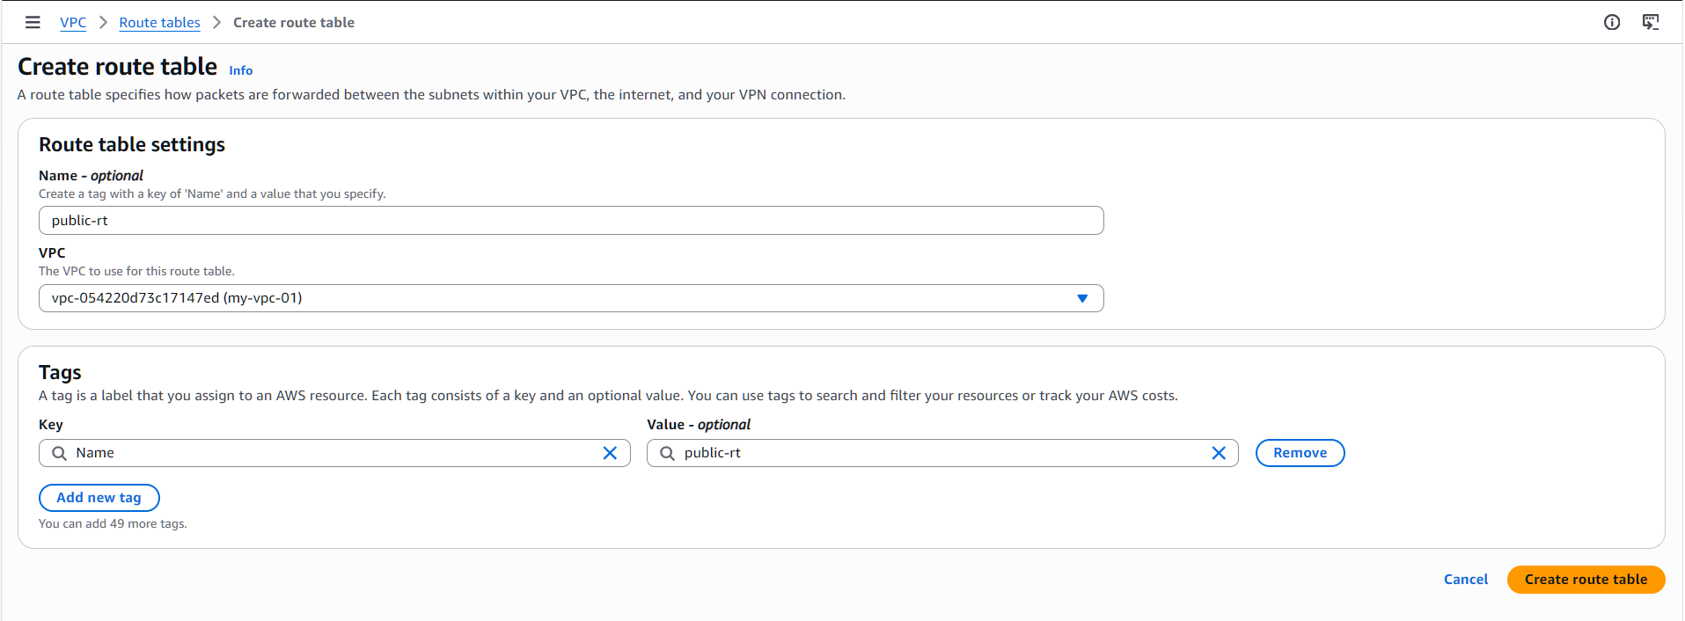

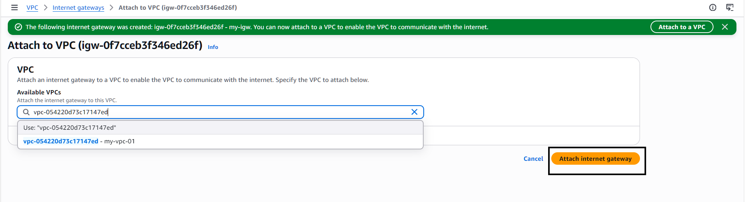
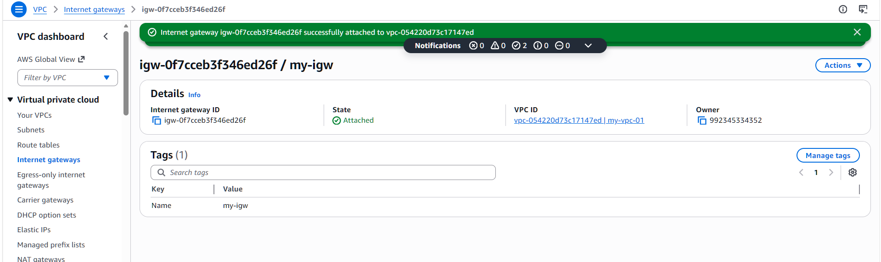
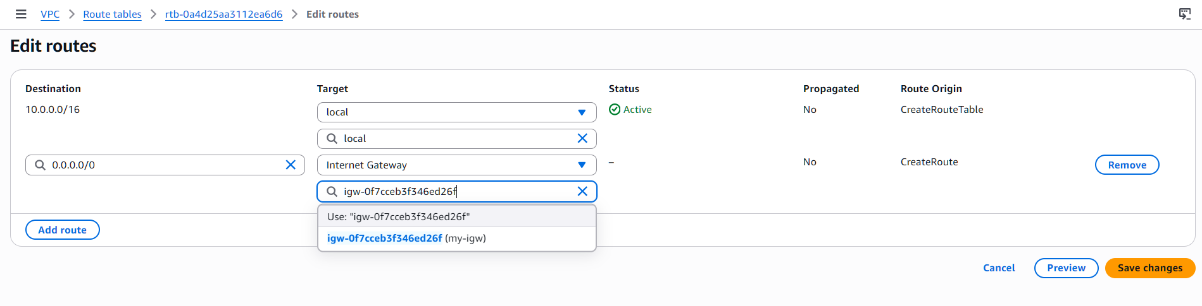
- Deploy a NAT gateway in the public subnet and attach the NAT gateway to the private subnet.
Created NAT Gateway in Public Subnet
Allocated Elastic IP for external communication
Updated Private Route Table with NAT Gateway route
Enabled secure internet access for Private Subnet
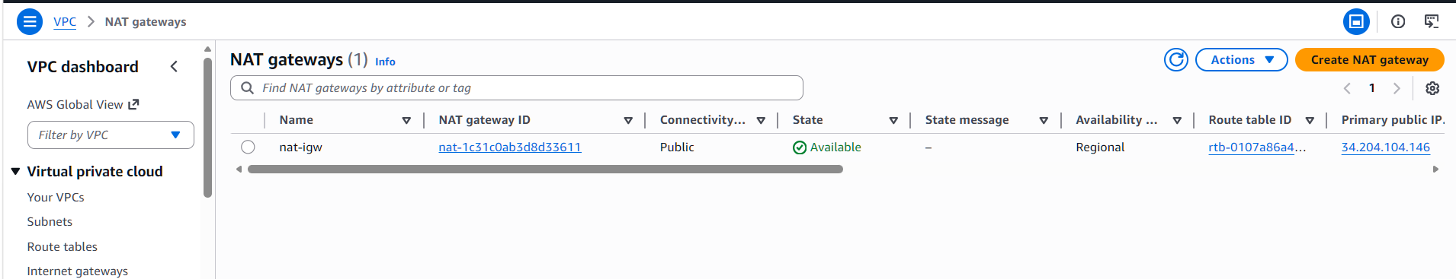
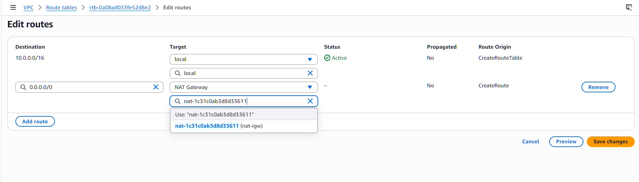
- Create two instances, one in the public subnet and one in the private subnet.
Launched two EC2 instances in VPC
Deployed one instance in public subnet with public IP
Deployed one instance in private subnet without public IP
Configured security groups for controlled access
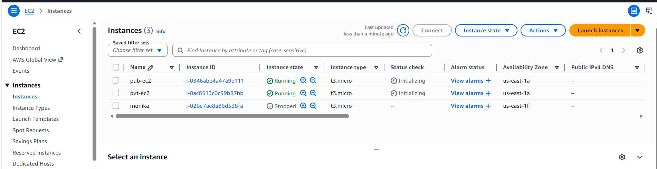

7Deploy Apache server on both EC2 instances with a sample index.html file.
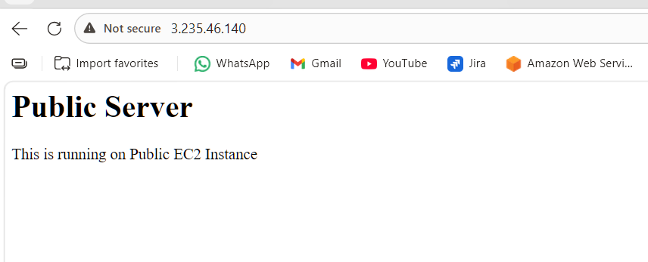

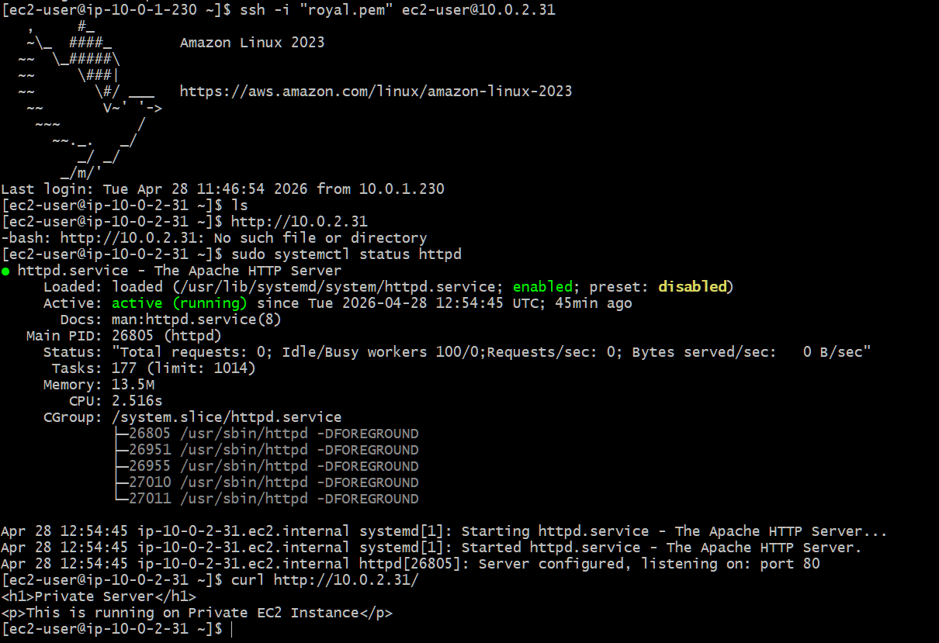
8.Create one application load balancer and attach it to both EC2 instances.
Created Application Load Balancer for traffic distribution
Configured ALB in public subnets
Created target group with EC2 instances
Attached target group to ALB
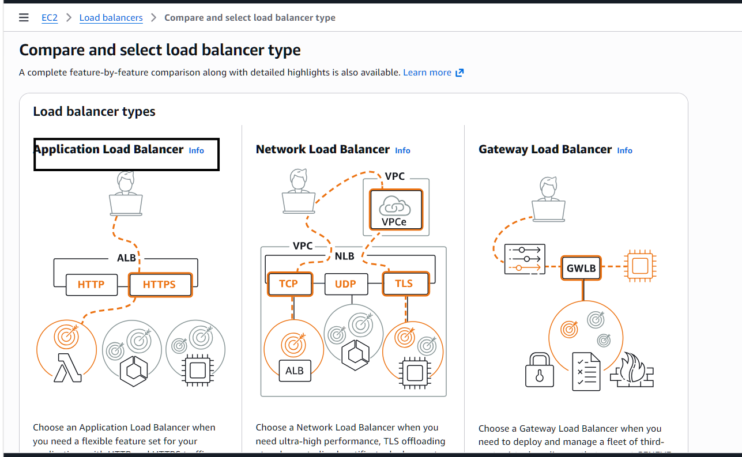
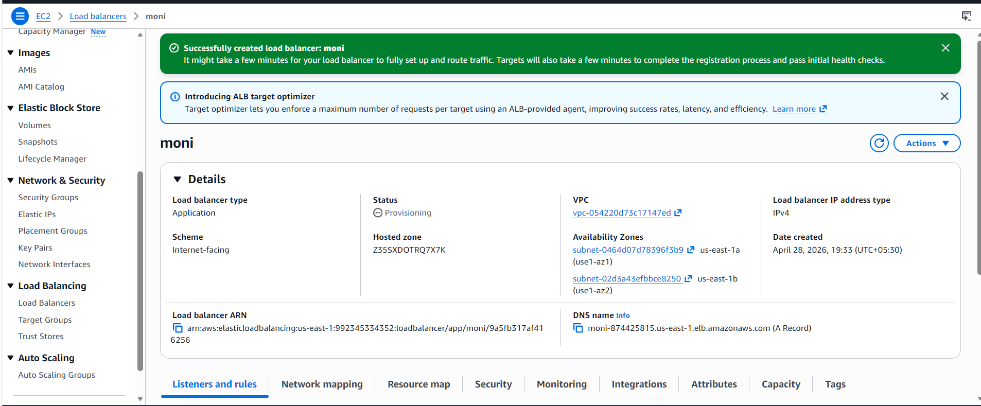
9.Store application load balancer logs in S3.
Created S3 bucket for storing ALB logs
Enabled access logging in ALB settings
Configured bucket policy for log delivery
Generated traffic to produce logs
Verified logs stored in S3 successfully
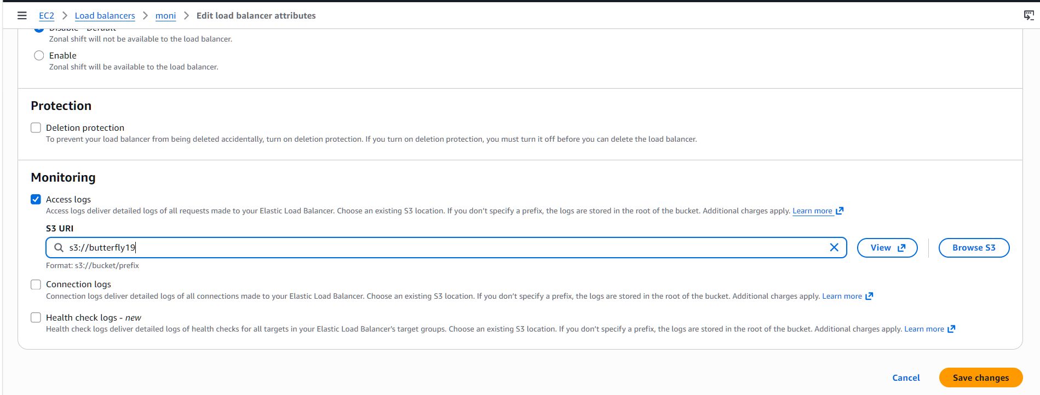
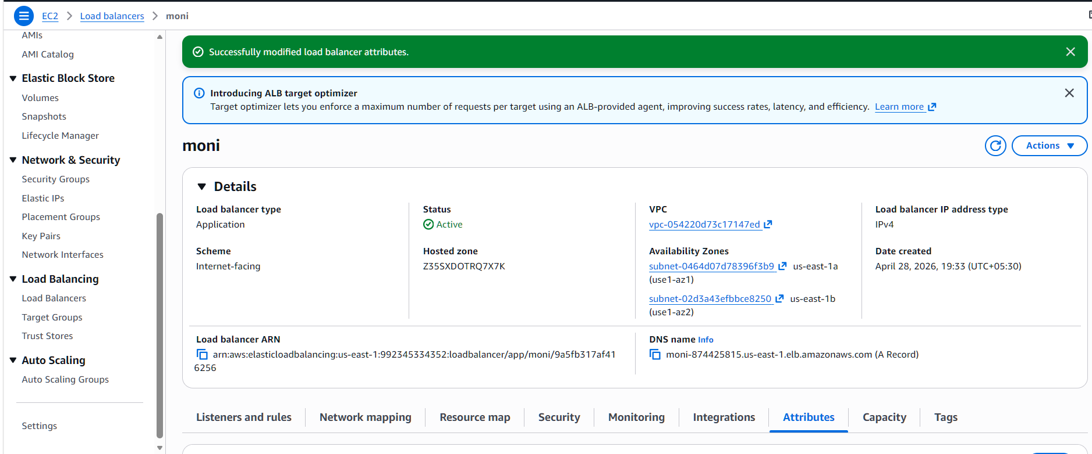

10.Store the VPC flow logs in a CloudWatch log group.
Configured VPC Flow Logs with CloudWatch destination
Created dedicated log group for network logs
Assigned IAM role for log delivery
Captured traffic at network interface level
Verified logs in CloudWatch log group
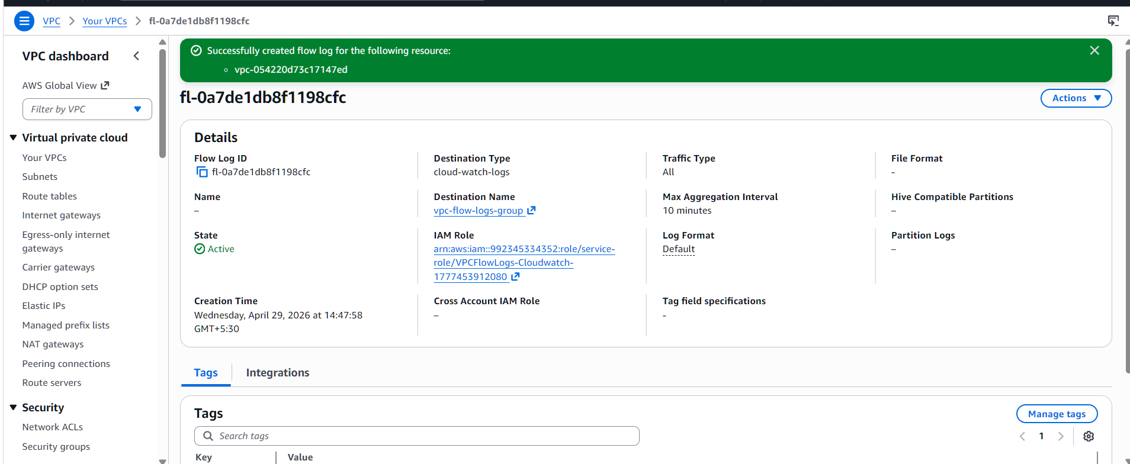
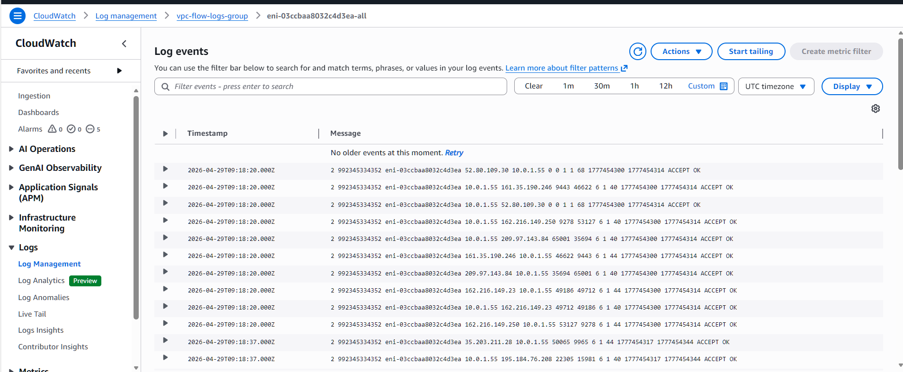

11.Create monitoring dashboards to monitor CPU utilization and to monitor the Apache service.
Created CloudWatch dashboard for system monitoring
Added CPU utilization metric for EC2 instances
Implemented custom metric for Apache service status
Visualized infrastructure and application performance
Enabled real-time monitoring and alerting capability
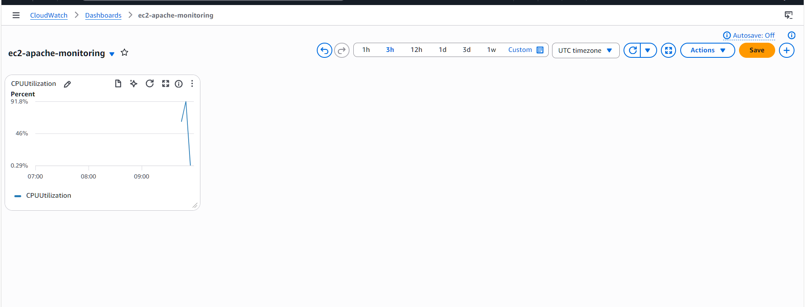
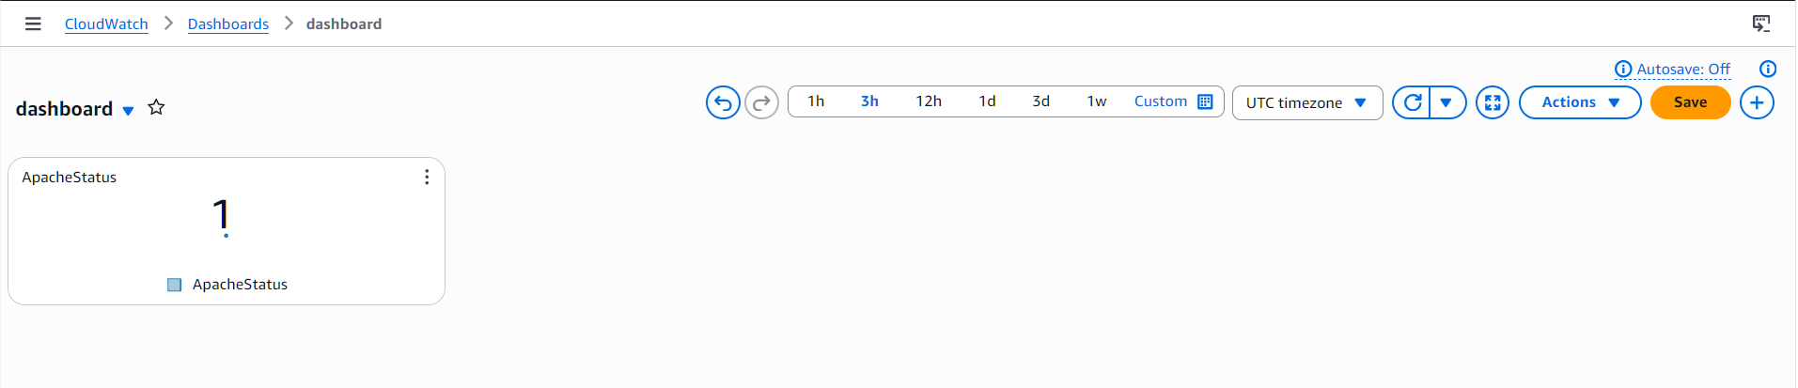
12.If CPU utilization is more than 70%, then it should trigger auto scaling and launch new instance.
Configured security group for EC2 instances
Allowed HTTP traffic for web access
Enabled SSH access for administration
Ensured compatibility with load balancer
Improved network accessibility and security

